BI
Mini Project
Sales Monitoring System

Document Control
Table of Contents
Reference No:
Security Classification: | iGATE Internal
Issue Date:
Author(s): | Name |  | Title
Author(s): | Rajita Dhumal |  | Dy Manager
Reviewer(s): | Name |  | Title
Issuer(s): | Name |  | Title
Issuer(s): | Rajita Dhumal |  | Dy Manager
Issuer Signature(s):
Distribution: | Name |  | Title
Distribution: | iLEARN |  | All Designations in iLEARN
Document History: | Date | Revision | Change
Document History: | Apr 2014 | 1.0 | Document creation
1 Introduction 4
1.1 Setup Checklist for Mini Project 4
1.2 Instructions 4
2 Problem Statement 5
2.1 Objective 5
2.2 Abstract of the project 5
2.3 Technology used: 5
3 Implementation in BI LOT 6
3.1 Summary of the functionality to be built: 6
3.2 Guidelines on the functionality to be built: 7
4 Evaluation and assessment parameters 11

Introduction

This document outlines a mini project for the BI LOT. The project is to develop Sales Monitoring System.
This document contains the work flow of the system and gives guidelines on how to build the functionality gradually in each of the course modules of the BI LOT.

Setup Checklist for Mini Project
Minimum System Requirements
- Intel Pentium 90 or higher (P166 recommended)
- Microsoft Windows 95, 98, or NT 4.0, 2k, XP, Windows 2007.
- Memory: 32MB of RAM (64MB or more recommended)
- Internet Explorer 6.0 or higher
- Oracle 9i client and access to oracle 9i server
- Informatica 9.5.1
- BOXI R4

Instructions
- The code modules in the mini project should follow all the coding standards.
- Create a directory by your name in drive <drive>. In this directory, create a subdirectory MiniProject. Store your Project here.
- You can refer to your course material.
- You may also look up the help provided in the BI docs and documentation provided with Informatica and Business Objects.

Problem Statement

Objective
Development of a Sales Monitoring System.

Abstract of the project
The aim of this project is to develop the fertilizers sales performance reports for “GREEN FERT LTD”. In this project, the analysis is performed based on the 5 years of sales data. The analysis has been done by taking into account the various entities like Retailers, Products, and Salesperson.
During the analysis, first design the Datawarehouse model by using the various aspects of dimensional modelling after ETL tool. Design the universe using SAP Business Object’s Information Design tool (IDT)..
Finaly, publishe the universe to create the required reports using SAP Business Object’s Web Intelligence Rich Client.

Technology used:
- Oracle 9i (Database)
- Informatica power center 9.5.1 (ETL Tool):-
- BusinessObjects XI Release 4

Implementation in BI LOT

Summary of the functionality to be built:
The participants need to develop the Sales Moniotring System by building the functionality incrementally in each of the course modules of BI LOT.

Sr. No | Course | Duration | No. of Saturdays | Functionality to be built
Sr. No | Course | (in PDs) | No. of Saturdays | Functionality to be built
1. | Programming Foundation using Pseudo code | 5 | 2
3. | Oracle | 7 | 2
4. | Unix | 4 | 2
5. | Oracle Test | 1 | 2
6. | Informatica 9.5.1 | 6 | 1 | Perform ETL to generate the fact tables and Dimension tables.
6. | Informatica 9.5.1 Test | 1 | 1
7 | BOXI | 5 | 1 | Create a Universe in BO and create Reports
8 | BOXI Test | 1 | 1 | Create a Universe in BO and create Reports
9 | OBIEE 11g | 5 | 1 | Create a package in framework Manager and create reports in Report Studio and Analysis Studio
10 | OBIEE 11g Test | 1 | 1

Guidelines on the functionality to be built:

Project flow

Heterogeneous Sources i.e. operational data (Flat files)
EXTRACT
TRANSFORM
LOAD
Data warehouse (Oracle)
Reports Based On Universe
UNIVERSE
(Informatica)
(BO IDT)
(BO XI Rich WebI/WebI)

Schema Design:

The project follows the start schema approach.
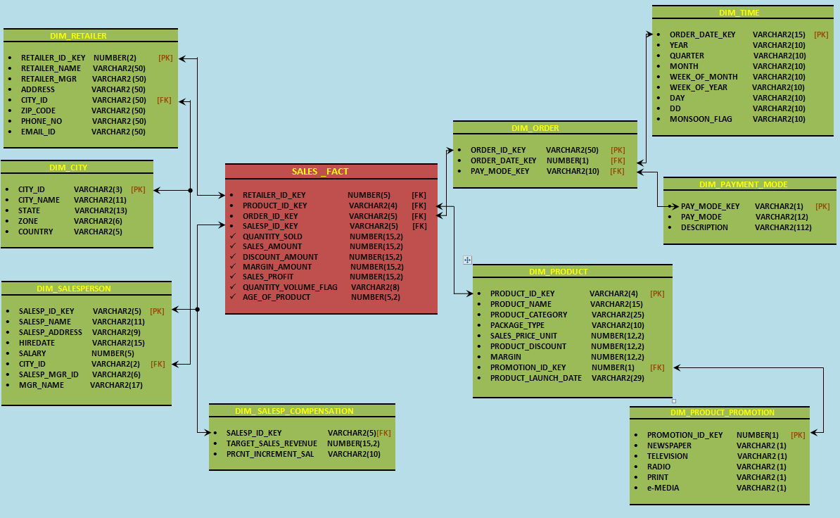
FACT_CENSUS_OCC
Person_id | Varchar
Door_num | Number(p,s)
Gender | Varchar
DOB | Varchar
Maritial_status | Varchar
Religion | Varchar
Caste | Varchar
Disability | Varchar
Type_of_disability | Varchar
status_of_attendance | Varchar
Occupation_id | Varchar
Occupation | Varchar
Nature_of_industry | Varchar
sector | Varchar
Salary | Number(p,s)

Note: The datatype/length for the Dimension/Fact table attribues can be changed as required. Additional fields can be added, if required.

Referred to the shared source files.

Evaluation and assessment parameters
This mini project will be done in groups of five or six. Each group will identify a Team Lead who will decide which team member will code for which functionality. This project shall be evaluated in two phases. Evaluation will be done using online presentation mode, where each group will present their respective modules.

Evaluation Parameters (100 Marks)
- ETL Scripts and DW design (25)
The extent to which the ETL was performed, the transformations used
Deliverables in terms of time lines
- Universe Design (35)
The way the universe was designed with appropriate classes and objects, conditions created
- Deliverables(Reports) (40)
Presentation of reports.

